Vegetation Community Monitoring Protocol for the Heartland Inventory and Monitoring Network

Standard Operating Procedure 10: Measuring Midstory and Overstory Trees

Version 3.00 (2018)

Revision History Log:

| Previous Version # | Revision Date | Author | Changes Made | Reason for Change | New Version # |
| --- | --- | --- | --- | --- | --- |
| 1.0 | 07/09 | KM James | Additional data collection | Add ability to track changes in stand structure | 2.0 |
| 2.0 | 2/2018 | SA Leis | Eliminate CPC, revise datasheet, clarify use of subplot, clarify tree species. | Eliminate subjective data that is rarely used. Improve clarity. | 3.0 |
|  |  |  |  |  |  |

This SOP gives step-by-step instructions for sampling the tree species located in the woodland layers of vegetation monitoring sites. Tree species data are most often collected in conjunction with the ground flora sampling since they utilize the same site. Tree classes are provided in Table 10.0. This SOP describes the procedure for collecting data and filling in the “Mid- and Overstory Tree Data Collection Form”. Canopy cover was formerly included in this SOP but has been extracted into its own SOP 9-Measuring Overstory Canopy.

**Table 10.0.** Diameter at breast height, DBH size class ranges for overstory and midstory trees.

| Size Class | Woodland Layer | DBH (cm) | SOP |
| --- | --- | --- | --- |
| Regeneration | Ground flora | < 5.0 | 7, Measuring Ground Flora |
| 1 | Midstory | 5 - 14.9 | 10, Measuring Midstory and Overstory Trees |
| 2 | Overstory | 15 - 24.9 | 10, Measuring Midstory and Overstory Trees |
| 3 | Overstory | 25 - 34.9 | 10, Measuring Midstory and Overstory Trees |
| 4 | Overstory | 35 - 44.9 | 10, Measuring Midstory and Overstory Trees |
| 5 | Overstory | 45+ | 10, Measuring Midstory and Overstory Trees |

Equipment

See SOP 5-Monitoring Site Setup for basic site set up equipment and procedures.

Additional equipment:

* 50 m measuring tape (2)
* DBH tape (2)
* Overstory datasheets, and prior site species list.
* Paddles and chalk
* Calipers
* Tree tags, stamping kit
* Tree nails
* Hammer
* Tree list
* Identification aids
* Binoculars
* Pruning shears (pole shears can be helpful but may not be practical)

Procedures

Set up the site as described in SOP 5-Monitoring Site Setup. Canopy cover measurements are collected along with the ground flora in the 10 m2 plots along each transect. Mid and overstory tree measurements are collected within the whole monitoring site as described below.

Figure 10.0. Diagram showing transect A which is typically on the uphill side with Transect B 20 m away and parallel to it. Each transect is 50 m long. 

**Figure 10.0**. Diagram displaying paired transects creating the 20 m x 50 m site for tree species sampling with the smaller 10 m2 herbaceous vegetation sampling subplots. Trees are measured in the 50 x 20 m block (1000 m2).

Once measurement tapes are stretched from start to finish for both transects, enter the following standard information on the top of Data Form “Mid- and Overstory Trees” (Figure 10.1).

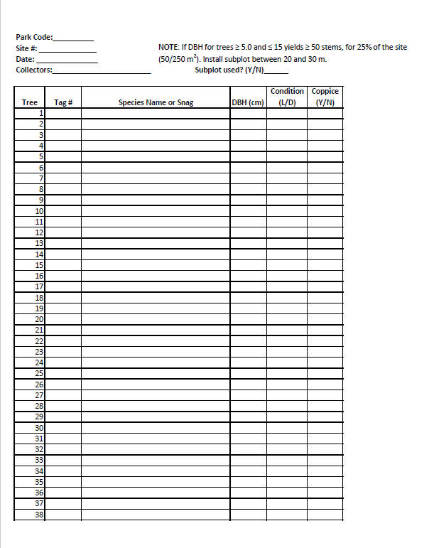

**Figure 10.1.** Overstory datasheet. Note that datasheet can be printed across multiple pages with continuous numbers in the tree field.

Datasheet terminology

**Site #:** This is the sample unit number located on the rebar tags at the beginning and end of each transect.

**Date (mm/dd/yyyy):** Write in the month (2 digits), day (2 digits) and year (4 digits) in the form shown. Include the forward slash. Examples are 05/02/2004 and 06/30/2004.

**Collectors:** Fill in the three initials of the people conducting the tree species surveys using capital letters. If you do not have a middle name, put an underscore for your middle initial. In the database, these initials will correspond to the full name and contact information for that person. (The 3-character initials in the database must be unique and if two people have the same initials, one should be given an honorary middle name.)

Some woody species can take both tree and shrub forms depending on the landscape context and disturbance history. The distinction of whether a plant is a shrub or tree (relevant to both the regeneration and overstory phases see Table 10.1 designation) is critical to knowing which observations are needed. To aid this process, we have developed a table that designates many of these problematic woody plants as shrubs (SOP 7-Measuring Ground Flora) or trees (this SOP, and *Regeneration methods* in SOP 7-Measuring Ground Flora) (protocol narrative, Table A1, also included here Table 10.1). Scribes should have a copy of Table 10.1 to consult in the field. If you are still unclear as to whether a species should be considered a tree or shrub, collect observations both as if the species in question is a tree (see SOP 7-Measuring Ground Flora for plot observations), and a shrub but flag these observations so that the project leader can designate them as the proper growth form prior to data entry. Prior to the field season, botanists should review the tree list (Table 10.1) along with prior species lists (see VegMon database) to create awareness of preferred data collection procedures.

Tree Measurement (see SOP 3-Establishing and Marking Permanent Sample Sites for tag installation procedures)

1. Working from the Start of the transects (0 m), move through the site systematically, taking care not to miss trees. Mark each tree using a chalk paddle as you measure it. This is done to ensure each tree is sampled only once. For sites with densely wooded areas, the area sampled for trees with DBH >5cm but <15 cm may be reduced to a 10 m x 20 m area (see 2a, Figure 10.2).
2. Measure all tree species within the site, both alive and dead, if >5 cm in DBH (diameter at breast height), in the 20 m x 50 m area (0.1 ha) located between transects A and B (Figure 10.0). Tree stems touching the site boundaries must be at least 50% within the site to be included in the sampling. For leaning dead (snag) trees when the DBH is <1 m above the ground, do not measure as overstory. For live trees that are leaning, continue to measure the DBH even if the tree becomes horizontal. This could occur in cases such as windthrow. Consider safety when assessing leaning and dead trees.

2a. Criteria for measuring a subplot fraction instead of the entire plot: If midstory trees (DBH ≥ 4.9 cm and ≤ 15.1 cm) are dense: (≥ 50 trees in 25% of the plot (= 50 trees/250 m2)) (USDI NPS 2003, p. 45). In that case, measure DBH of midstory trees in a subset of the site only, as shown in Figure 10.2. The 10 m x 20 m subsite will be centered in the site between 20 and 30 meters. Trees > 15 cm in DBH will be measured across the whole 50 m X 20 m site.

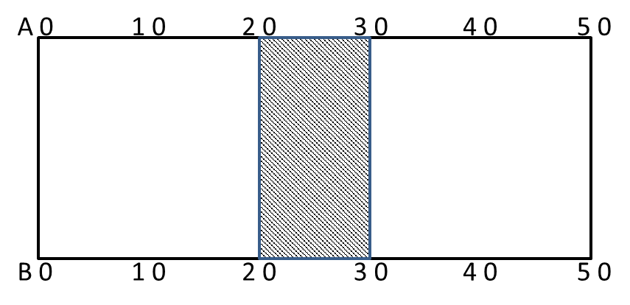

**Figure 10.2.** Diagram displaying paired transects creating the 20 m x 50 m site for tree species sampling with the provisional (if density is ≥ 50 trees/250 m2) 10 m x 20 m subplot for measuring tree species >5 cm and <15 cm DBH. Trees >15 cm DBH will be measured in the entire site.

1. Each tree is identified to species, if possible. Tree species are recorded using a species code consisting of the first four letters of both the genus and the specific epithet as a minimum. For example, record *Quercus velutina* as QUER VELU. For *Acer* species write out the whole name as two species have the same 4x4 letter code.

Diameter at breast height (DBH) is measured at 1.372 m (4.5 feet) from the root collar. If the tree is tagged, place the tape just above the nail, making sure the tape is perpendicular to (the ground? the stem?) and does not sag. SOP 3-Establishing and Marking Permanent Sample Sites describes tag installation. Measure both live and standing dead (snags). Dead trees’ species name is recorded as “snag”. Trees are considered alive if they have any living parts (leaves, buds, cambium) at or above the point of diameter measurement. Trees that have been temporarily defoliated are still alive.

For leaning trees, find the appropriate measuring location by leaning or measuring along with the lean of the tree. In sloping areas, breast height is measured from the root collar on the uphill side of tree. Diameter at breast height is measured to the nearest tenth of a centimeter. If a distortion of the bole occurs at 1.372 m, DBH is measured just above the distortion. Trees with trunks that divide below 1.372 m are coppice trees. For these, measure the DBH of each stem if the coppice is at least 1/3 the area of the bole and less than 45° from vertical. Coppice stems more than 45° from vertical are considered branches and are not measured. Trees whose trunks divide above 1.372 m are measured as one tree and given a single DBH. All overstory trees are recorded on the data form “Midstory and Overstory Tree Data Collection Form”. Additional detail on measuring unusual conditions is in Figure 10.3 and the text following it.

1. A condition code is assigned to each tree using the following codes:

L = Live

D = Dead, Standing Dead, Snag

A designation of coppice form (Yes or No) is also recorded. This refers to whether the tree branches below breast height. If it does, measure each of the coppiced branches and record with species and DBH.

**Table 10.1.** Woody species plant type categorization. This list includes the vast majority of species that have potential to cause confusion in the field. See SOP7-Measuring Ground Flora and this SOP for methods for trees, tree regeneration, and shrub plant types

| Species Code | Species name | Plant type |
| --- | --- | --- |
| ACNE2 | *Acer negundo* | tree |
| ACRU | *Acer rubrum* | tree |
| ACSA2 | *Acer saccharinum* | tree |
| ACSA3 | *Acer saccharum* | tree |
| AEGL | *Aesculus glabra* | tree |
| ALNUS | *Alnus* spp. | tree |
| AMELA | *Amelanchier* spp. | tree |
| AMAR3 | *Amelanchier arborea* | tree |
| AMLA | *Amelanchier laevis* | tree |
| ARSP2 | *Aralia spinosa* | shrub |
| BETUL | *Betula* spp. | tree |
| BENI | *Betula nigra* | tree |
| BEPA | *Betula papyrifera* | tree |
| CACA18 | *Carpinus caroliniana* | tree |
| CARYA | *Carya* spp. | tree |
| CAAL27 | *Carya alba* | tree |
| CACO15 | *Carya cordiformis* | tree |
| CAGL8 | *Carya glabra* | tree |
| CAOV2 | *Carya ovata* | tree |
| CATE9 | *Carya texana* | tree |
| CAPUO | *Castanea pumila var. ozarkensis* | tree |
| CEOC | *Celtis occidentalis* | tree |
| CELTI | *Celtis* spp. | tree |
| CETE | *Celtis tenuifolia* | tree |
| CECA4 | *Cercis canadensis* | tree |
| CORNU | *Cornus* spp. | shrub |
| COAL2 | *Cornus alternifolia* | tree |
| CODR | *Cornus drummondii* | shrub |
| COFL2 | *Cornus florida* | tree |
| COFO | *Cornus foemina (*ID likely *drummondii*) | shrub |
| CORA6 | *Cornus racemosa* | shrub |
| CORU | *Cornus rugosa* | shrub |
| CRATA | *Crataegus spp* | tree |
| DIVI5 | *Diospyros virginiana* | tree |
| ELUM | *Elaeagnus umbellata* | shrub |
| EUAT3/EUAT5 | *Euonymus atropurpureus* | shrub |
| FRCA13 | *Frangula caroliniana* | tree |
| FRAXI | *Fraxinus* spp. | tree |
| FRAM2 | *Fraxinus americana* | tree |
| FRNI | *Fraxinus nigra* | tree |
| FRPE | *Fraxinus pensylvanica* | tree |
| GLTR | *Gleditsia triacanthos* | Tree |
| ILDE | *Ilex decidua* | tree |
| ILOP | *Ilex opaca* | tree |
| JUNI | *Juglans nigra* | tree |
| JUNIP | *Juniperus* spp. | tree |
| JUVI | *Juniperus virginiana* | tree |
| LIVU | *Ligustrum vulgare* | Tree |
| LIBE3 | *Lindera benzoin* | shrub |
| LIST2 | *Liquidambar styraciflua* | Tree |
| LITU | *Liriodendron tulipifera* | Tree |
| MAPO | *Maclura pomifera* | tree |
| MALUS | *Malus* spp. | tree |
| MORUS | *Morus* spp. | tree |
| MOAL | *Morus alba* | tree |
| MORU | *Morus rubra* | tree |
| NYSY | *Nyssa sylvatica* | tree |
| OSVI | *Ostrya virginiana* | tree |
| PIEC2 | *Pinus echinata* | tree |
| PIPO | *Pinus ponderosa* | tree |
| PIST | *Pinus strobus* | tree |
| PLOC | *Platanus occidentalis* | tree |
| POPUL | *Populus* spp. | tree |
| POGR4 | *Populus grandidentata* | tree |
| POTR5 | *Populus tremuloides* | tree |
| PRUNU | *Prunus* spp*.* | tree |
| PRAM | *Prunus americana* | shrub |
| PRHO | *Prunus hortulana* | tree |
| PRPU3 | *Prunus pumila* | shrub |
| PRSE2 | *Prunus serotina* | tree |
| PRVI | *Prunus virginiana* | shrub |
| PTTR | *Ptelea trifoliata* | tree |
| QUERC | *Quercus* spp. | tree |
| QUAL | *Quercus alba* | tree |
| QUCO2 | *Quercus coccinea* | tree |
| QUEL | *Quercus ellipsoidalis* | tree |
| QUIM | *Quercus imbricaria* | tree |
| QUMA2 | *Quercus macrocarpa* | tree |
| QUMA3 | *Quercus marilandica* | tree |
| QUMU | *Quercus muehlenbergii* | tree |
| QUPA2 | *Quercus palustris* | tree |
| QURU | *Quercus rubra* | tree |
| QUSH | *Quercus shumardii* | tree |
| QUST | *Quercus stellata* | tree |
| QUVE | *Quercus velutina* | tree |
| REDOAK | *Red oak group* | tree |
| RHAMN | *Rhamnus* spp. | shrub |
| RHCA3 | *Rhamnus cathartica* | shrub |
| RHLA | *Rhamnus lanceolata* | shrub |
| RHCO | *Rhus copallinum* | shrub |
| RHGL | *Rhus glabra* | shrub |
| ROPS | *Robinia pseudoacacia* | tree |
| SANIC4 | *Sambucus nigra ssp. canadensis* | shrub |
| SAAL5 | *Sassafras albidum* | tree |
| SILAA4 | *Sideroxylon lanuginosum ssp. albicans* | shrub |
| SILAL3 | *Sideroxylon lanuginosum ssp. lanuginosum* | shrub |
| STTR | *Staphylea trifolia* | shrub |
| TIAM | *Tilia americana* | tree |
| ULMUS | *Ulmus spp* | HOME and PIPE prairie-shrub  Elsewhere-tree |
| ULAL | *Ulmus alata* | tree |
| ULAM | *Ulmus americana* | tree |
| ULPU | *Ulmus pumila* | tree |
| ULRU | *Ulmus rubra* | tree |
| VIBUR | *Viburnum (both)* | shrub |
| VIDE | *Viburnum dentatum* | shrub |
| VILE | *Viburnum lentago* | shrub |
| VIPR | *Viburnum prunifolium* | shrub |
| VIRU | *Viburnum rufidulum* | shrub |
| WHTOAK | *White oak group* | tree |
| ZAAM | *Zanthoxylum americanum* | shrub |

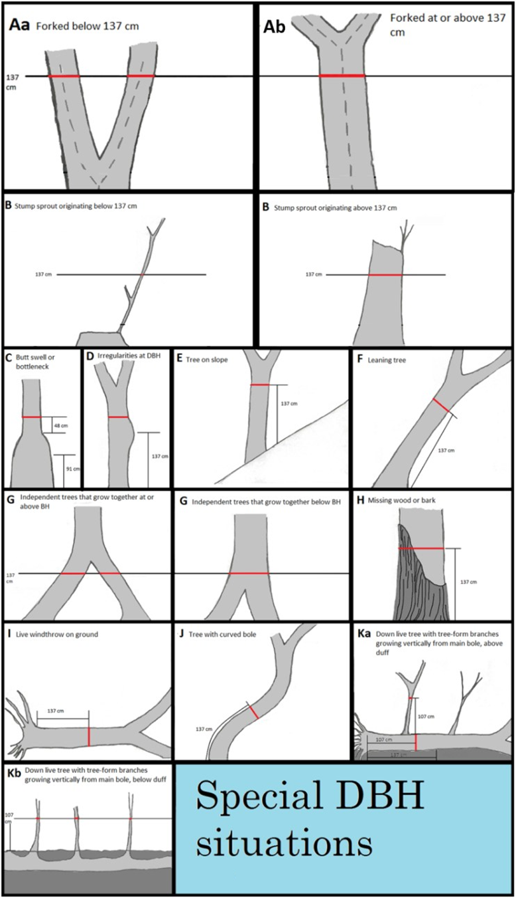

**Figure 10.3.** Illustration of rules for measuring diameter for forked trees for those species measured at breast height. Red, horizontal lines on stems indicate location at which diameter should be measured for the given situation (taken from Symstad et.al. 2012).

Special DBH situations:

NOTE: All stems of branched trees measured at DBH are recorded as separate trees, regardless of the type of forking. Always tag all forks of a forked tree, following the same procedure as for unforked trees.

1. Forked tree: In order to qualify as a fork, the stem in question must be at least 1/3 the diameter of the main stem (“bole”) and must branch out from the main stem at an angle of 45 degrees or less**. Forks originate at the point on the bole where the piths intersect.** Forked trees are handled differently depending on whether the fork originates below 137 cm, or above 137 cm.
   1. Trees forked below 137 cm: Trees forked below 137 cm are treated as distinctly separate trees for recording and tagging purposes. DBH is measured for each stem at 137 cm above the ground (Figure 10.3Aa). Multiple forks are possible if they all originate from approximately the same point on the main stem. In such cases, measure DBH on all stems at 137 cm above the ground.
   2. Tree forks at or above 137 cm: Trees forked at or above 137 cm count as one single tree (Figure 10.3Ac). If a fork occurs at or immediately above 137 cm, measure diameter below the fork just beneath any swelling that would inflate DBH.
2. Stump sprouts: Stump sprouts originate between ground level and 137 cm on the boles of trees that have died or been cut. Stump sprouts >5 cm at DBH are recorded as individuals. Stump sprouts are measured at 137 cm from ground line.
3. Trees with irregularities at BH: On trees with swellings, bumps, depressions, and branches at BH, measure diameter immediately above (preferably) or below the irregularity at the place it ceases to affect normal stem form (Figure 10.3D).
4. Tree on slope: Measure the diameter at 137 cm from the ground along the bole on the uphill side of the tree (Figure 10.3E).
5. Leaning tree: Measure the diameter at 137 cm from the ground along the bole. The 137 cm distance is measured along the underside face of the bole (Figure 10.3F). Do not measure snags where breast height is < 6 feet above the ground.
6. Independent trees that grow together: If two or more independent stems have grown together at or above BH, treat them as separate trees. Estimate the diameter of each and explain the situation in the notes (Figure 10.31G).
7. Missing wood or bark: Do not reconstruct the DBH of a tree that is missing a small amount of wood or bark at the point of measurement. Record the diameter of the wood and bark that is still attached to the tree. If a **large** part of the bole is missing (*e.g.,* on a broken-off snag) it may be necessary to reconstruct DBH (Figure 10.3H).
8. Live wind-thrown tree on the ground: Measure diameter at the point 137 cm along the stem from the top of the root collar (Figure 10.3I).
9. Tree with curved bole: Measure along the bole on the side slope side (upper surface) of the tree (Figure 10.3J).
10. Down live tree with tree-form branches/sprouts growing vertical from main bole: When a down live tree, touching the ground, has vertical (< 45° from vertical) tree-like branches coming off the main bole, first determine whether or not the pith of the main bole is above or below the duff layer (Figure 10.3K).
    1. If the pith of the main bole is above the duff layer, use the same forking rules specified for a forked tree, and take all measurements accordingly (Figure 10.3Ka).
       1. If the pith intersection of the main down bole and vertical tree-like branch occurs less than 137 cm from the root collar along the main bole, treat that branch as a separate tree, and measure diameter 107 cm above the pith intersection for both the main bole and the tree-like branch.
       2. If the pith intersection between the main down bole and the tree-like branch occurs beyond 137 cm from the root collar along the main bole, treat that branch as part of the main down bole (*i.e.*, its diameter is not measured).
    2. If the pith of the main tree bole is below the duff layer, ignore the main bole, and treat each tree-like branch as a separate tree; take diameter and length measurements from the ground, not necessarily from the top of the down bole. However, if the top of the main tree bole curves out of the ground towards a vertical angle, treat that portion of that top as an individual tree originating where the pith leaves the duff layer (Figure 10.3Kb).

Literature Cited

Symstad, A. J., R. A. Gitzen, C. L. Wienk, M. R. Bynum, D. J. Swanson, A. D. Thorstenson, and K. J. Paintner-Green. 2012. Plant community composition and structure monitoring protocol for the Northern Great Plains I&M Network - Standard Operating Procedures: Version 1.01. Natural Resource Report NPS/NRPC/NRR—2012/489.1. National Park Service, Fort Collins, Colorado.

USDI National Park Service. 2003. Fire Monitoring Handbook. Boise (ID): Fire Management Program Center, National Interagency Fire Center. 274p.